**WarLOG**

**Prepared by**

Rahul Desai(18DCE024)

Shaunak Patel(18DCE086)

Saumya Raval(18DCE104)

**Under the guidance of**

Prof. Chandrashekhar Pawar

A Report Submitted to

Charotar University of Science and Technology

for Partial Fulfillment of the Requirements for the

4th Semester Internship (CE244)

**Submitted at**



**CE**

**DEPSTAR**

**At: Changa, Dist: Anand – 388421**

**July 2020**



**CERTIFICATE**

This is to certify that the report entitled “**WarLOG**” is a bonafied work carried out by **Rahul Desai (18DCE024), Shaunak Patel(18DCE086), Saumya Raval(18DCE104)** under the guidance and supervision of **Prof.Chandrashekhar Pawar**for the subject **Summer Internship(CE244)** of 4th Semester of Bachelor of Technology in **Computer Engineering** at Faculty of Technology & Engineering (D.P.I.A.T.R) – CHARUSAT, Gujarat.

To the best of my knowledge and belief, this work embodies the work of candidates themselves, has duly been completed, and fulfills the requirement of the ordinance relating to the B.Tech. Degree of the University and is up to the standard in respect of content, presentation and language for being referred to the examiner.

Under the supervision of,

Prof.ChandrashekhaPawar

Assistant Professor,

Devang Patel Institute of Advance Technology & Research

Changa-388421, Gujarat, India.

Dr. (Prof.) Amit Ganatra Dean,

Faculty of Technology & Engineering

Head, Devang patel Institute of Advance Technology & Resarch, CHARUSAT- Changa, Gujarat.

**INRODUCTION**

**Gaming in the field of software engineering**

* In the fast growing field of software engineering and development and even more rapidly growing sector of game development the future is hard to predict.
* We are working with this game as our software project lab-II.SPL-II is a 3 credit course and as part of our degree we choose this type of work for doing better with development cycle, development period, graphics, scripting, adopting new technology, animation.
* In general software project is a project focusing on the creation of software. Consequently, Success can be measured by taking a look at the resulting software.
* In a game project, the product is a game. But and here comes the point: A game is much more than just its software. It has to provide content to become enjoyable.
* Just like a web server: without content the server is useless, and the quality cannot be measured. This has an important effect on the game project as a whole.
* The software part of the project is not the only one, and it must be considered in connection to all other parts:
* The environment of the game
* The story
* Characters
* Game plays

**About the project**

* It’s a complete strategy game with real time multiplayer logic. Two fighters or teams who are fighting with Guns using different powers.
* Main Mission of the gamers is to use this power and save themselves form another fighter.
* This Game have lots of different types of Guns and Powers. The gamer is to use his logic and kill other players.

**Scope of Game**

* This Report describes all the requirements for the project.
* The purpose of this research is to provide a virtual image for the combination of both structured and unstructured information of our project “WARLOG”.
* “WARLOG” is a multi-player strategy game. It runs on any computer.
* We demonstrate the action flow between inputs, script, display (output).
* We are working mainly with levels, object, animation, graphics, scripts, game engine facilities.

**OBJECTIVES**

* The **objective** of our **game** is to achieve a certain number of victory points before all other players by hitting them with the weapons provided in the game.
* There are many levels/stages in game where your rank decides your difficulty level.
* It is a multiplayer game so two or more players will fight with each other and one will be the winner with highest kill.
* The player who struggle till the end of the round will be rewarded with points and achievements
* There are so many things are presented in form of reward like new gun skin, new robot theme and many more.
* This rewards will be given in systematic way there are particular post given to each player like General Commander, Red level soldier

**PROBLEM DEFINATION & BENIFITS**

**About existing Gaming Market**

* The Indian digital gaming industry is growing rapidly, with behemoths like Alibaba backed-Paytm, Tencent, Youzu and Nazara investing in it.
* Our Country is one of the[top five countries](https://inc42.com/buzz/india-5-online-mobile-gaming-report/) for gaming in the world, the industry is already worth over [$890 million](https://timesofindia.indiatimes.com/business/india-business/indian-gaming-industry-to-grow-in-double-digits-mos-it/articleshow/56959809.cms) and with the demand for games on an upward curve.
* The country now has more than 250 game development companies, up from a mere 25 in 2010, with at least two start-ups coming up every month.
* The rise in the popularity of gaming is partly due to the increased accessibility that the public has to them; at the tap of a screen, one can download games onto a smart device.
* Evidently, the increase in mobile gaming has run in parallel to the rise in smartphone adoption in India, which is set to have[530 million smartphone](http://indianexpress.com/article/technology/india-set-to-have-530-million-smartphone-users-in-2018-study-4893159/)users this year.
* Many game developers such as Moon Frog, 99Games, Play Simple and Mech Mocha are capitalizing on the growth in smartphone usage to build their businesses.

**Drawback and Problem with Existing Game**

* The main advantage of Extreme Programming is that this methodology allows software development companies to save costs and time required for project realization.
* They usually solve problems through discussions inside of the team.
* Time savings are available because of the fact that XP focuses on the timely delivery of final products.

**User Benefits**

* Playing WarLog enables the player to greatly enhance his/her judgment capability and make impromptu decisions.
* Playing an action games make a good sense of creating strategies in any field.
* Our game is so well deigned that it interface makes users/players mood fresh.
* WarLog is so amusing game that every player will greatly experience the game which totally makes player enjoy the game.
* Playing our game user/player will feel fresh and more energetic which helps him/her to do other work in better way.

**SYSTEM REQUIRMENTS**

**Hardware Requirements**

* Processor (CPU) with 2 gigahertz (GHz) frequency or above.
* A minimum of 4 GB of RAM
* Monitor Resolution 1024 X 768 or higher.
* A minimum of 20 GB of available space on the hard disk
* Keyboard and a Microsoft Mouse or some other compatible pointing device
* Sound card
* Speakers or headphones

**Software Requirements**

* OS: 64/32-bit Windows 7, Windows 8.1, Windows 10.
* Visual Studio
* Unity

**FRONT END SYSTEM**

**Unity Studio**

* Unity is a cross-platform game engine developed by Unity Technologies.
* Unity is a fully integrated development engine that provides rich out-of-the-box functionality that allows you to create amazing Games and other interactive 2D + 3D content.
* Improvements for audio include real-time mixing and Mastering that now allows you to create detailed mixing graphs.

**BACK END SYSTEM**

**Visual Studio**

* Microsoft **Visual Studio** is an integrated development environment (IDE) from Microsoft.
* It is used to develop computer programs, as well as websites, web apps, web services and mobile apps. ...
* Built-in languages include C, C++, C++/CLI, **Visual Basic** .NET, **C#**, F#, JavaScript, TypeScript, XML, XSLT, HTML, and CSS.
* **Microsoft Visual Studio** is an [integrated development environment](https://en.wikipedia.org/wiki/Integrated_development_environment) (IDE) from [Microsoft](https://en.wikipedia.org/wiki/Microsoft).
* It is used to develop [computer programs](https://en.wikipedia.org/wiki/Computer_program), as well as [websites](https://en.wikipedia.org/wiki/Web_site), [web apps](https://en.wikipedia.org/wiki/Web_app), [web services](https://en.wikipedia.org/wiki/Web_service) and [mobile apps](https://en.wikipedia.org/wiki/Mobile_app).
* Visual Studio uses Microsoft software development platforms such as [Windows API](https://en.wikipedia.org/wiki/Windows_API), [Windows Forms](https://en.wikipedia.org/wiki/Windows_Forms), [Windows Presentation Foundation](https://en.wikipedia.org/wiki/Windows_Presentation_Foundation), [Windows Store](https://en.wikipedia.org/wiki/Windows_Store) and [Microsoft Silverlight](https://en.wikipedia.org/wiki/Microsoft_Silverlight).
* It can produce both [native code](https://en.wikipedia.org/wiki/Native_code) and [managed code](https://en.wikipedia.org/wiki/Managed_code).

**SYSTEM AYALISIS AND DESING**

**System development Lifecycle**

* Our project developed using specific software development lifecycle.
* Software development approach is best suited for the project depends on the requirement and other factors.
* A process model is a development strategy that is used to achieve a goal that satisfies the requirement abiding by the constraints.
* We are using the **Spiral Model** for our project.

**Spiral Model:**

* The spiral model is a risk-driven process model generator for software projects.

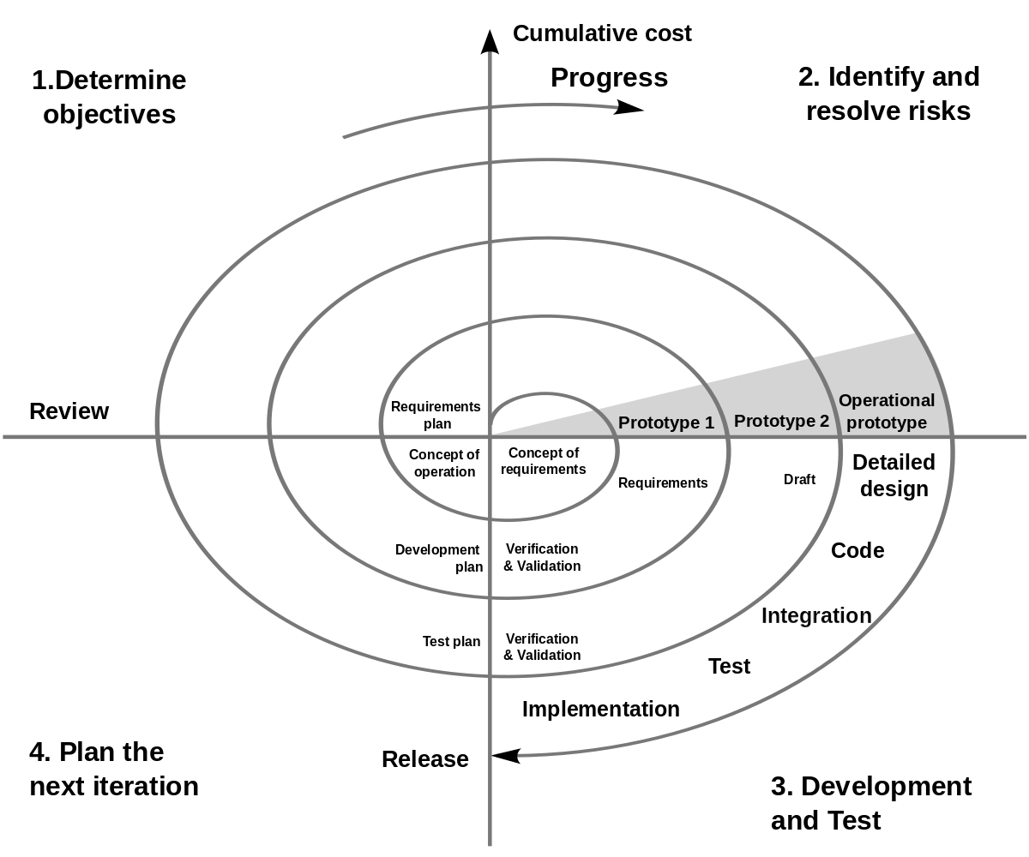

**Identifies activities of system (Primary)**

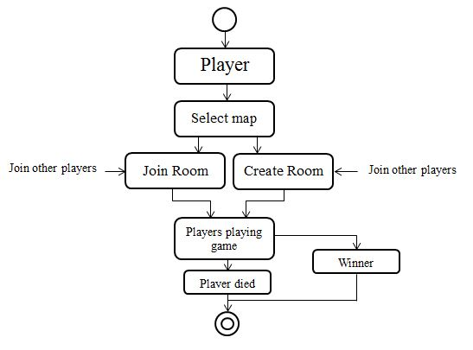

**Feasibility Study**

* A game feasibility study is a formal project proposal used to secure internal or external funding and resources for a game development project.
* It is designed to assess the business and technical potential/problems of the proposed project i.e. can we make it, if so can we make at a profitable level.
* After the study, the game project is either further developed or cancelled.
* The study is an expansion upon the game concept.
* Writing and researching a study may involve gathering feedback and information from other Eirplay senior staff, especially marketing input and the Development Manager.
* You may need to perform some market research and analysis on the concept.
* The game feasibility study should include a revised version of the game concept.
* It might also suggest modifying or adding features

.

**The game feasibility study includes the following features:**

* Revised game concept (preceding)
* Technical analysis
* Legal analysis (if applicable)
* Cost and revenue projections
* Art

**DFD (Data Flow Diagram)**

* Level 0

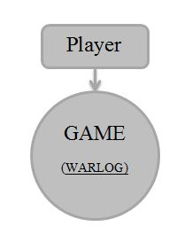

* Level 1

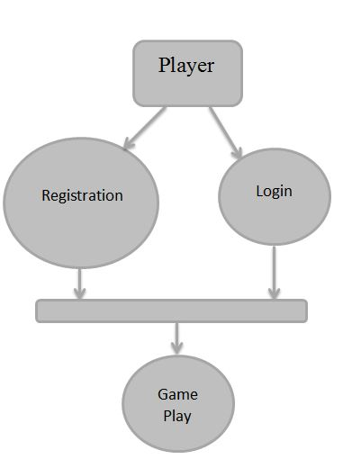

* Level 2

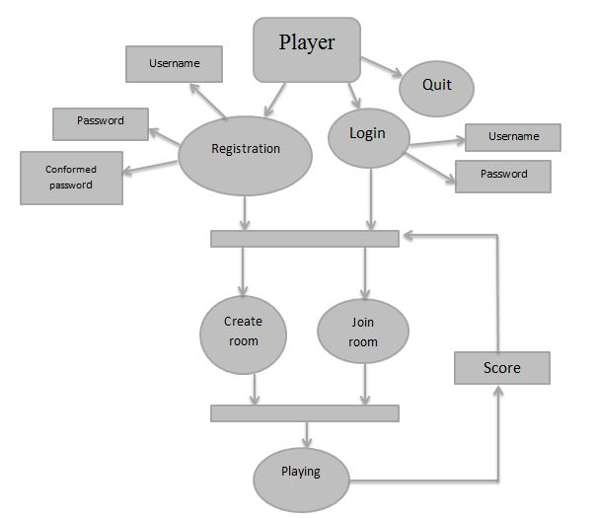

* Used Case

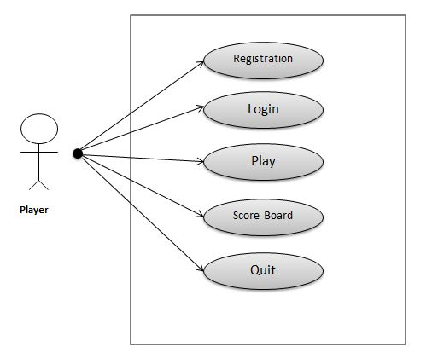

**Data Dictionary**

* Registration Form

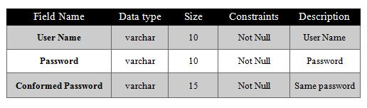

* Login Form

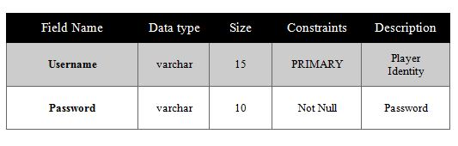

* ER-Diagram

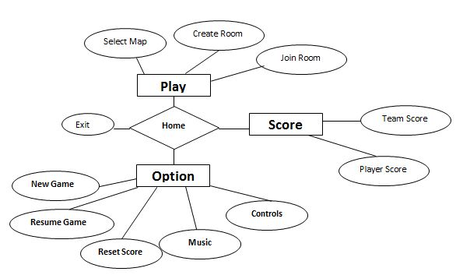

**Form Layout**

**(LOGIN Form)**

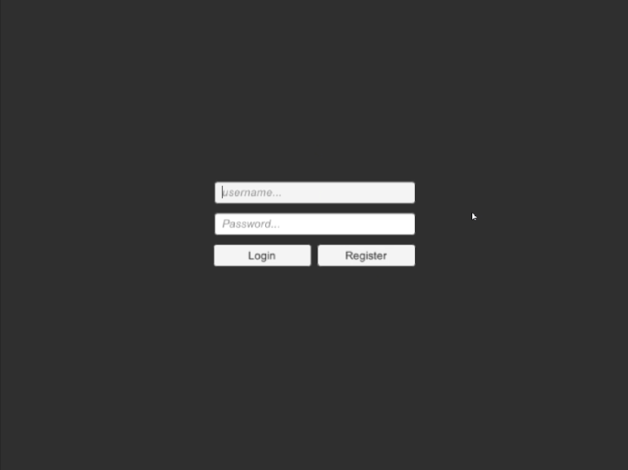

* This is a Login page of WarLog game.
* In this Login Page user must be enter Email address & Password.
* When user login through Email address & Password then identify the

specific user on Internet.

**(Registration Form)**

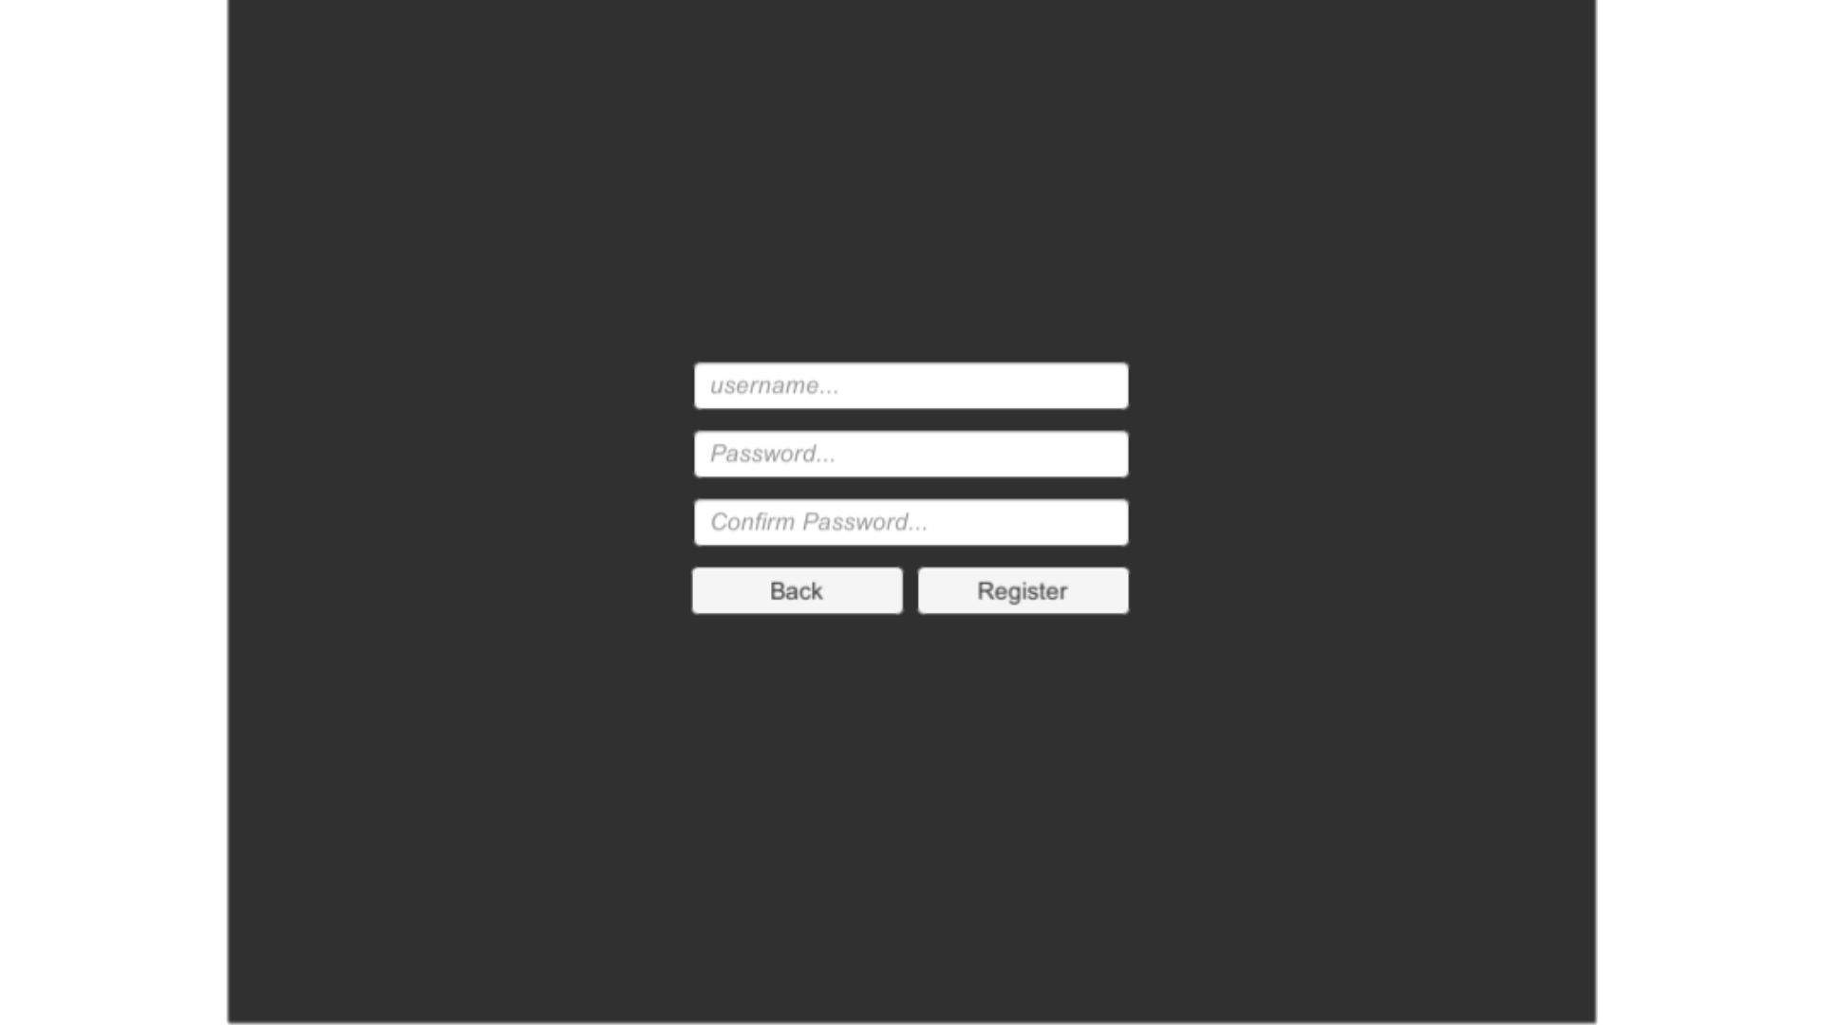

* This is a Signup of WarLog game.
* In this Login Page user must be Register username , Password ,

Conformed Password.

* User must be first register basic Information on Signup page then

Login on login page.

**(Home Page)**

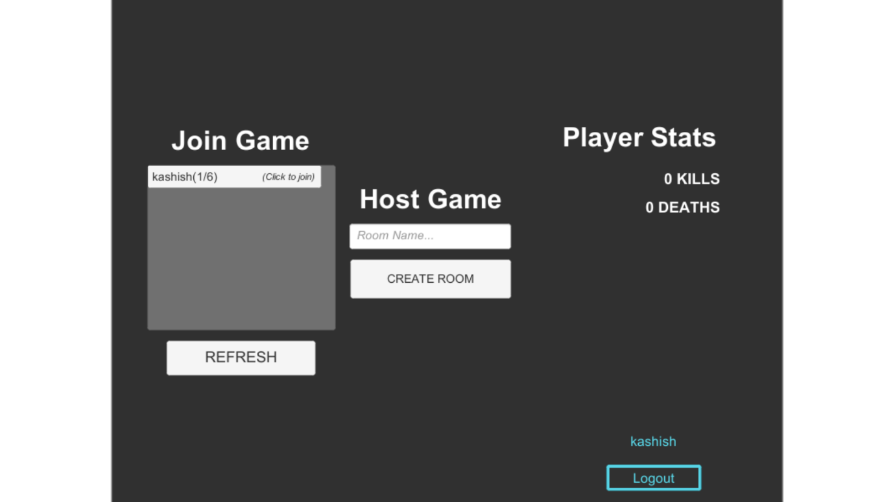

* This is a Home page of WarLog Game.
* In this page
* Play - User play WarLog game.
* Option - User display or play types of player on game.
* Score - Display user previous game.
* Languages – User select comfortable language.
* Exit – Exit from Game.

**(Game Play)**

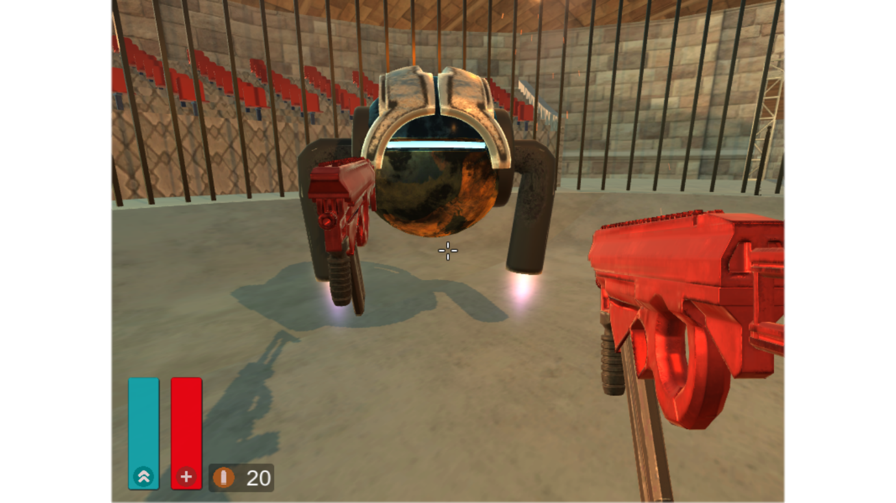

* This is basic layout of WarLog Game.
* We added gun , environment object in this game.
* We have also add flying capability of player.

**(Score Board)**

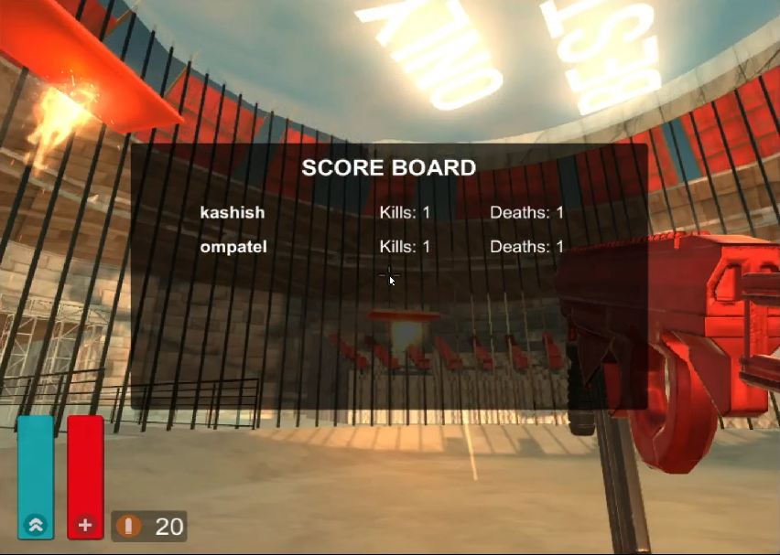

* This is Score board of WarLog Game.
* Score Board Counts Kills and Deaths of Players

In Game.

* Score Board Show using “Tab” button in Playing Mode.

**(Exit Game)**

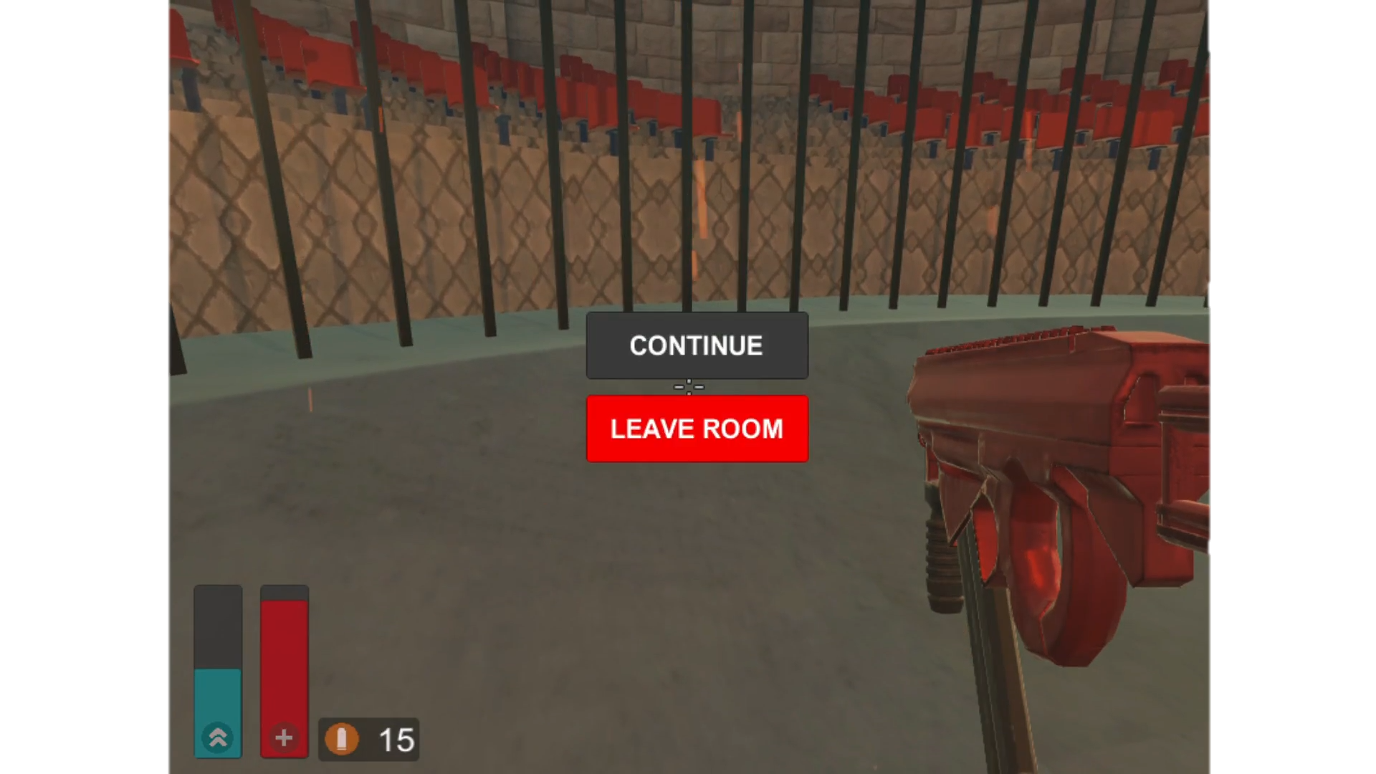

* When Player Exit Game then this Layout shows.
* Player exit Game using “esc” Button in Playing Mode

**(Arena Stage)**

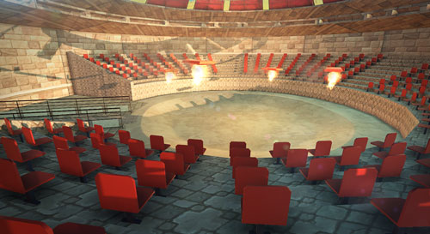

* This is arena stage of WarLog Game,
* All Player Player Plays 3D Multiplayer Game

Using this stage.

**System Features of Our Game**

* This Game has lots of Guns, Bombs, Powers, Maps facilities.
* Powers Like
* Double Bomb
* Mini M4
* The Jumper
* Health
* Shilled
* Invisible Drinks
* Random Etc.

**Further Enhancement**

* Capture the flag is available and different modes are also Available.
* New Weathers and Improve graphical representation.
* Available in Android Mobiles.
* Vehicles and different objects are available.
* New Guns and Powers Etc.
* Take user response through website and produce web rank list
* Introduce new game features

**Conclusion**

* A software project means a lot of experience. In this section we summarize the experience gained by project team during development of “WARLOG”.
* The future of the educational gaming industry is a wide-open playing field so we will get lots of experiences from this WarLog project.
* Making a game is very useful to improve our loops, graphics and Database’s logic.
* If any kind of suggestion, improvements, more efficient development idea please feel free to communicate with us.

**BIBILIOGRAPHY**

* To develop this game we need so much of help which we took all from internet, books and some magazine.
* There reference became too much helpful to us through which we are able to understand the concept of game development.
* As we came to know game development is a long procedure we started doing internet and study the concept.

**Website Reference**

* We take help of Google where many game developers had made many games on there on.
* Then we got more knowledge from git hub where many coding references are available which makes some sense for or work.
* Watching there videos and practicing more and more makes us perfect.
  + [www.google.com](http://www.google.com)
  + [www.github.com](http://www.github.com)
  + [www.youtube.com](http://www.youtube.com)
    - [www.brackeys.com](http://www.brackeys.com)
  + [www.unity.com](http://www.unity.com)
  + [www.digitaltrends.com](http://www.digitaltrends.com)
  + [www.visual.microsoft.com](http://www.visual.microsoft.com)

**Book Reference**

* We choose visual studio for our back end coding where we work with c# and j#.
* There are to many reference books of C# and J# Like..
* C# 4.0 (Herbert Schildt)
* Visual J# .NET (John Sharp, Andy Longshaw, Peter Roxburgh)
* C# 2008 ([Christian Gross](http://it-ebooks.directory/author-228.html))